Portfolio Project

Evan Hofstadter
Colorado State University Global
CSC450: Programming 3
Professor Russell Frith
Nov 8 2026

Section 1: Source Code

package PortfolioProject;

public class ConcurrencyCounter {

private static final int MIN_COUNT = 0;

private static final int MAX_COUNT = 20;

private static final int MAX_LABEL_LEN = 32;

private static final long WAIT_TIMEOUT_MS = 5000L;

// Private final lock object prevents external lock hijacking (CERT LCK00-J)

private final Object lock = new Object();

private int sharedCounter = MIN_COUNT;

private boolean countUpCompleted = false;

private boolean abortFlag = false;

private static String sanitizeLabel(String rawLabel) {

if (rawLabel == null || rawLabel.isEmpty()) {

return "Unnamed-Thread";

}

int boundedLen = Math.min(rawLabel.length(), MAX_LABEL_LEN);

StringBuilder clean = new StringBuilder(boundedLen);

for (int i = 0; i < boundedLen; i++) {

char c = rawLabel.charAt(i);

// Allow only printable ASCII characters to block newline/log injection

if (c >= 32 && c <= 126) {

clean.append(c);

}

}

return clean.toString();

}

// Thread 1 counts up from 0 to 20, then notifies Thread 2.

public void countUp(String label) {

final String cleanLabel = sanitizeLabel(label);

// Pre-sized StringBuilder avoids creating immutable String garbage on every

// loop

StringBuilder localLog = new StringBuilder(512);

synchronized (lock) {

try {

sharedCounter = MIN_COUNT;

while (sharedCounter <= MAX_COUNT) {

localLog.append("[").append(cleanLabel).append("] counting up: ")

.append(sharedCounter).append(System.lineSeparator());

if (sharedCounter == MAX_COUNT) {

break;

}

sharedCounter = Math.addExact(sharedCounter, 1);

}

// Flushing buffered output once minimizes I/O blocking inside synchronized

// block

System.out.print(localLog.toString());

countUpCompleted = true;

lock.notifyAll();

} catch (ArithmeticException ex) {

abortFlag = true;

System.err.println("[ERROR in " + cleanLabel + "]: " + ex.getMessage());

lock.notifyAll();

}

}

}

// Thread 2 waits until Thread 1 reaches 20 then counts down to 0.

public void countDown(String label) {

final String cleanLabel = sanitizeLabel(label);

StringBuilder localLog = new StringBuilder(512);

synchronized (lock) {

try {

long deadline = System.currentTimeMillis() + WAIT_TIMEOUT_MS;

while (!countUpCompleted && !abortFlag) {

long remaining = deadline - System.currentTimeMillis();

if (remaining <= 0L) {

System.err.println("[ERROR in " + cleanLabel + "]: Timed out waiting for Thread 1.");

return;

}

lock.wait(remaining);

}

if (abortFlag) {

System.err.println("[ERROR in " + cleanLabel + "]: Aborted due to error in Thread 1.");

return;

}

while (sharedCounter >= MIN_COUNT) {

localLog.append("[").append(cleanLabel).append("] counting down: ")

.append(sharedCounter).append(System.lineSeparator());

if (sharedCounter == MIN_COUNT) {

break;

}

// Math.subtractExact prevents silent 32-bit integer underflow

sharedCounter = Math.subtractExact(sharedCounter, 1);

}

System.out.print(localLog.toString());

} catch (InterruptedException ie) {

// Restores interrupted state

Thread.currentThread().interrupt();

System.err.println("[ERROR in " + cleanLabel + "]: Thread was interrupted while waiting.");

} catch (ArithmeticException ex) {

System.err.println("[ERROR in " + cleanLabel + "]: " + ex.getMessage());

}

}

}

public static void main(String[] args) {

System.out.println("Hello worl...Concurrency Counter (but java this time)!");

ConcurrencyCounter counter = new ConcurrencyCounter();

Thread thread2 = new Thread(() -> counter.countDown("Thread 2"), "CountDown-Thread");

Thread thread1 = new Thread(() -> counter.countUp("Thread 1"), "CountUp-Thread");

// Start Thread 2 first to prove it safely waits on the monitor lock until

// Thread 1 reaches 20

thread2.start();

thread1.start();

try {

thread1.join();

thread2.join();

} catch (InterruptedException e) {

Thread.currentThread().interrupt();

System.err.println("[FATAL ERROR]: Main thread interrupted while joining worker threads.");

}

System.out.println("Tah-dah!");

}

}

Section 2: Screenshots 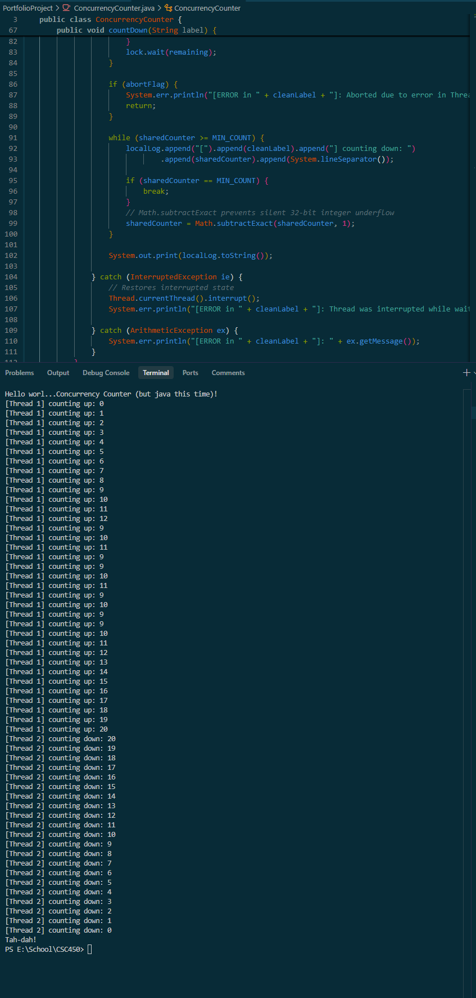

Section 3: Security Analysis
In using multithreading to run parallel workloads, and through the memory and arithmetic behaviors of Java on the JVM, this program has several key layers of security to consider.

- Issues with Concurrency on Performance
  - Lock contention: multithreaded Java programs typically enter a synchronized block every loop and write directly to System.out.println(). Similar to in C++, console I/O is a slow system call and the thread holding the monitor lock during that output will block other threads and cause lock contention. Here, I had each thread write its output as a StringBuilder in memory, then flush the completed buffer once using System.out.print() before releasing the lock. As in C++, this reduced the lock acquisitions from 42 down to 2 for this program.
- String Vulnerability
  - Heap Exhaustion: Since Java Strings are immutable objects, modifying strings in a loop allocates a new object on the heap for each iteration. With the thread labels repeated 21 times per thread, passing an unbounded string could exhaust heap memory. My sanitizeLabel() method prevents that by checking for null, enforcing a 32-character limit with MAX_LABEL_LEN = 32, and allocating a mutable StringBuilder preemptively instead of concatenating immutable strings.
  - Log Injection: If an input string contains hidden newline or other control characters, attackers can inject fake lines into the console output. SanitizeLabel() prevents this by filtering the label so only printable ASCII characters (those between 32 and 126) are kept.
- Data Type Security
  - Silent Integer Overflow: Unlike C++, Java guarantees that int is always a signed 32-bit integer regardless of platform, which allows the countdown loop to safely subtract down to 0. However, standard Java + and - operators silently wrap around if a number exceeds the 32-bit limit without throwing an error. To prevent that silent overflow/underflow, I used Java’s built-in Math.addExact()/subtractExact() methods, which throw ArithmeticException immediately if the counter goes out of bounds.

Section 4: Detailed Comparison Between Performance Implementations Between the Java and C++ Versions of My Applications
Developing the same multithreaded counter application in both C++ and Java highlights a fundamental trade-off in software engineering: raw hardware performance of C++ versus the built-in runtime safety of Java. Both applications were designed to accomplish the same concurrency task: using a first thread to count up from 0 to 20, and synchronizing a second thread to wait until 20 is reached by the first to then count from 20 down to 0. Additionally, both programs were hardened against the same core issues: lock contention during I/O operations, string-related memory and injection vulnerabilities, and integer overflow or underflow. Despite sharing the same functional goal, the underlying architecture of C++ and Java required noticeably different implementation strategies. While the C++ implementation delivers superior execution speed and lower memory overhead due to native compilation and deterministic resource management, the Java implementation is significantly less vulnerable to security threats because memory safety, bounds checking, and thread lifecycle protections are enforced directly by the Java Virtual Machine (JVM).
When comparing performance between the two implementations, C++ holds a distinct advantage in startup latency, memory footprint, and execution speed. This difference begins with how each language is compiled and executed. The C++ application is compiled ahead-of-time (AOT) directly into native machine instructions for the host operating system. When the C++ executable runs, the operating system loads the binary into memory and immediately begins executing CPU instructions with zero virtual machine overhead (Stroustrup, 2013). In contrast, the Java source code is compiled into intermediate bytecode (.class files) that must be interpreted and compiled at runtime by the JVM. Before the Java application even prints its first line, the JVM must initialize its runtime environment, load core class libraries, and allocate heap spaces. While Java’s Just-in-Time (JIT) compiler can optimize frequently executed code paths over long-running workloads, a short program that only counts to 20 and back finishes long before JIT optimizations can offset the initial JVM startup cost.
Memory management also creates a noticeable performance gap between the two implementations. In the C++ version, variables such as the ConcurrencyCounter instance, the TargetThread wrappers, and the local string streams are allocated deterministically on the stack or managed through Resource Acquisition Is Initialization (RAII). As soon as a variable goes out of scope at a closing brace, its destructor runs immediately and frees the associated memory without pausing the program. In the Java version, almost every component, including the ConcurrencyCounter object, the Object monitor lock, the Thread instances, and the String and StringBuilder buffers, must be dynamically allocated on the JVM heap. Reclaiming this memory relies on the JVM Garbage Collector (GC). Although both programs used local buffering (std::ostringstream in C++ and StringBuilder in Java) to reduce console I/O calls and cut mutex acquisitions from 42 to 2, Java’s reliance on heap allocation and garbage collection introduces higher memory overhead and potential non-deterministic GC pauses that do not exist in C++ (Goetz et al., 2006).
Finally, the threading and synchronization primitives differ slightly in runtime cost. Both C++’s std::thread and Java’s java.lang.Thread map one-to-one onto operating system kernel threads, meaning both incur similar OS-level context-switching costs when transitioning between Thread 1 and Thread 2. However, C++’s std::mutex and condition_variable act as zero-overhead wrappers over native OS synchronization primitives. In Java, entering a synchronized (lock) block requires the JVM to manage object monitor headers, track thread ownership metadata, and check JVM safepoints. While this monitor overhead is negligible in a 20-step counter, in high-throughput systems it gives C++ a measurable edge in synchronization latency.
Although C++ wins on raw speed and memory efficiency, the Java implementation is considerably less vulnerable to security threats. Throughout the development of both programs, a clear pattern emerged: in C++, security relies heavily on the programmer remembering to write defensive scaffolding around every operation, whereas in Java, the most dangerous classes of vulnerabilities are eliminated by the language design and the JVM sandbox (Seacord, 2013).
The most significant security difference lies in memory safety and string handling. In C++, strings and buffers are historically one of the largest sources of critical vulnerabilities, including buffer overflows and over-reads. Traditional C-style strings rely on a trailing null-terminator byte to mark the end of a string; if a buffer lacks a null terminator or exceeds its allocated size, the program will read or write into adjacent stack or heap memory, allowing attackers to corrupt memory or execute arbitrary code. To make the C++ version safe, I had to explicitly use std::string_view to pair a memory pointer with an explicit length, and write a dedicated StringChecker::sanitizeLabel() namespace function that reserved buffer capacity via clean.reserve() and stripped out % format specifiers. In Java, raw memory pointers and manual buffer allocations do not exist at the developer level. Every Java String and array is an object managed by the JVM with strict, automatic bounds checking. If a Java program attempts to read one character past the end of a string, the JVM immediately halts the operation and throws a StringIndexOutOfBoundsException rather than allowing adjacent memory to be read or overwritten (Long et al., 2014). While sanitizeLabel() was still useful in Java to prevent log injection and cap string length at 32 characters, Java is inherently immune to the classic buffer overflow and missing null-terminator exploits that plague C++.
A second major area where Java is less vulnerable is concurrency lifecycle management and undefined behavior. In C++, thread management is unforgiving: if a std::thread object goes out of scope before .join() or .detach() is called - for example, if an unexpected exception is thrown - the C++ runtime immediately invokes std::terminate(), crashing the entire application. To prevent this denial-of-service risk in C++, I had to build a custom RAII wrapper class (TargetThread) with an explicit destructor (~TargetThread()) and deleted copy constructors. Additionally, under the C++ memory model, a data race on a shared variable or a signed integer overflow is classified as Undefined Behavior (UB). When UB occurs in C++, the compiler is permitted to make assumptions that can corrupt program state or bypass security checks entirely. In contrast, Java eliminates undefined behavior at the language level. The Java Memory Model (JMM) guarantees type safety and memory integrity even in the presence of concurrency bugs, and an unjoined Thread object will never trigger an abrupt process termination. Similarly, Java’s synchronized (lock) block guarantees that the monitor lock is automatically released when execution leaves the block, even if an uncaught exception occurs, removing the risk of forgotten unlock calls causing permanent deadlocks (Goetz et al., 2006).
Finally, data type security and arithmetic checking are much more standardized and built-in with Java. In C++ the standard int data type does not have a guaranteed bit size across all hardware architectures (the C++ standard only guarantees at least 16 bits). To ensure consistent 32-bit behavior and prevent undefined signed overflow in C++, I had to include <cstdint>, enforce std::int32_t, and manually write boundary checks against the maximum and minimum numeric limits inside AddNumChecker::addNums(). In Java, the language specification strictly mandates that an int is always a 32-bit signed two’s-complement integer across every operating system and CPU architecture. While standard Java addition can still wrap around silently on overflow, Java provides built-in checked arithmetic methods (Math.addExact() and Math.subtractExact()) inside the standard java.lang.Math library (Long et al., 2014). Replacing custom boundary math with tested standard library methods reduces code complexity and lowers the chance of human error.
Comparing the C++ and Java counter implementations illustrates why both languages remain essential in modern computing, depending on the priorities of the project. The C++ version provides unmatched control over memory layout, zero virtual-machine startup delay, and minimal runtime overhead, making it ideal for performance-critical systems programming where every microsecond and megabyte counts. However, that performance comes at the cost of requiring extensive manual defensive coding such as custom RAII thread wrappers, fixed-width integer types, and manual overflow checks, just to keep what is a very simple program safe. The Java implementation trades a small amount of startup speed and heap memory for a much more secure execution environment. By enforcing automatic bounds checking, eliminating raw pointers, standardizing 32-bit data types across platforms, and providing native monitor locks and checked math functions, Java significantly reduces the attack surface and is the less vulnerable implementation against common security threats.

References:
Goetz, B., Peierls, T., Bloch, J., Bowbeer, J., Holmes, D., & Lea, D. (2006). Java concurrency in practice. Addison-Wesley Professional.
Long, F., Mohindra, D., Seacord, R. C., Sutherland, D. F., & Svoboda, D. (2014). The CERT Oracle secure coding standard for Java. Addison-Wesley Professional.
Seacord, R. C. (2013). Secure coding in C and C++ (2nd ed.). Addison-Wesley Professional.
Stroustrup, B. (2013). The C++ programming language (4th ed.). Addison-Wesley Professional.

Section 5: GIT repo
The repo for this project (CSC450 portfolio project) can be found here: https://github.com/ehofstadter/CSC450-Portfolio-Project

